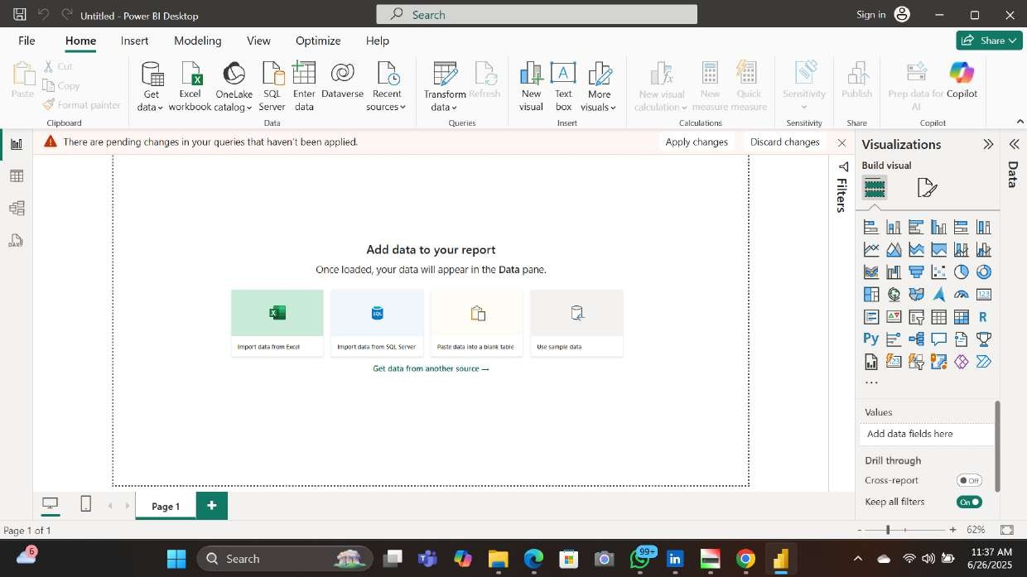

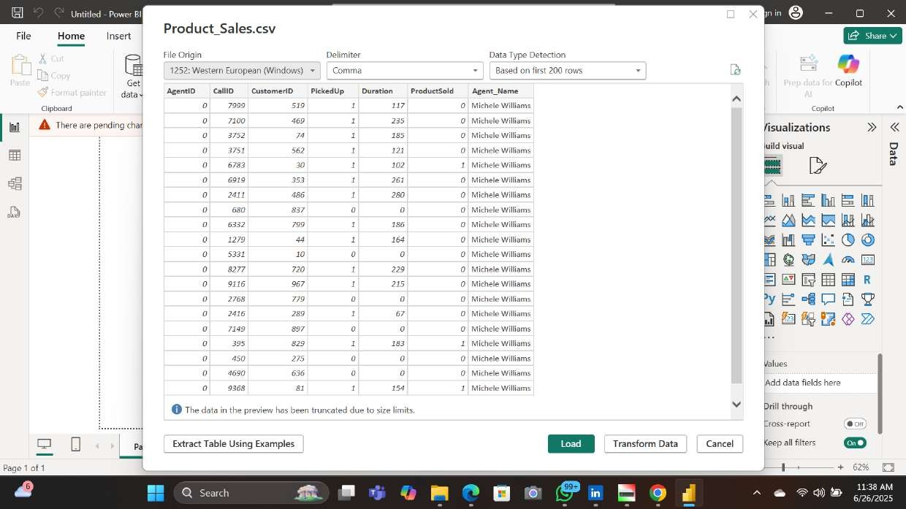

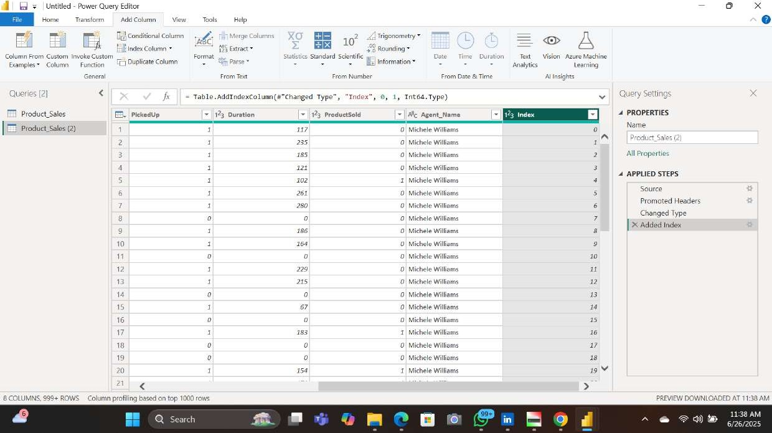

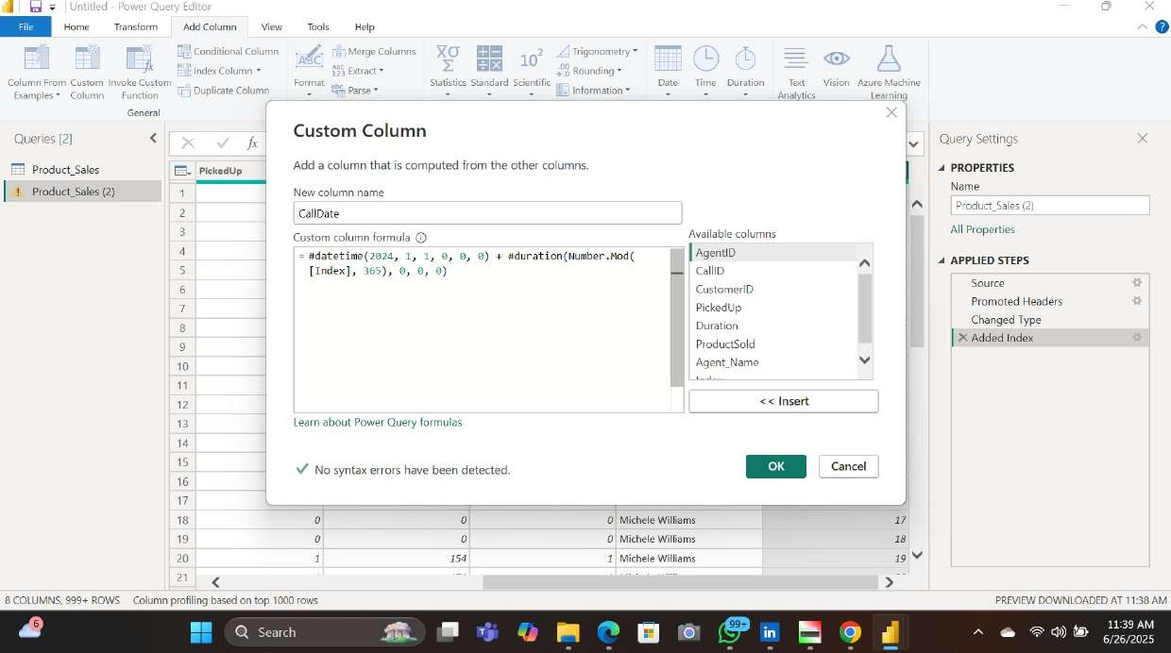

- Query

# XO

10

Ind.* column La 3 Rounding •

Column CL.Stun Statistics Scientific Date Time Text Vision

Duplicate Cdumn

Examples - Analytics Leerning

|  |  |  |
| --- | --- | --- |
| Table . | custom", ({"ca11Date" , | type date}} ) |

From The Al Insights

|  |
| --- |
| proraated Headers  Type  Index  Custom  Typef |

|  |  |  |  |  |  |  |
| --- | --- | --- | --- | --- | --- | --- |
| PrGuct_SaIes |  | Duration | i 123 | ABC Agent_Name |  | PROPERTIES |
| Product_SaIes (2) | 2 |  |  | 0 Michele Williams  O Michele Willianu  O Michele  Michele  1 Michele Williams | 1/1/2020  1/2/2024 1/*'2024 d/4/2024 1/5/2024 | Name  All Properties  APPLIED STEPS |

QueriesQuery Settings

Source

0 Michele Williams 1/6/2024

O MicheleVVilliamS 1/7/2024

1/8/2024 Changed

Michele Williams

Added

01 Michele WilliMnR 1/9/202-1

Added

Williams 1/20/2024 Changed

Michele Williams 1/11/2024 0 Michele Williams 3/1772024

Mich"'le Williams v'18/2024

14 0 Michele Williams 1/14/2024

O Michele Williams V15,'2024

O Michele la 6/2024

1. Michele 1/17/2024
2. MicheleWiIIiams 1/18/2024

O Michele Williams 1/19/2024

Michele Williams J/20/2024 V

ROWS AT

11-40